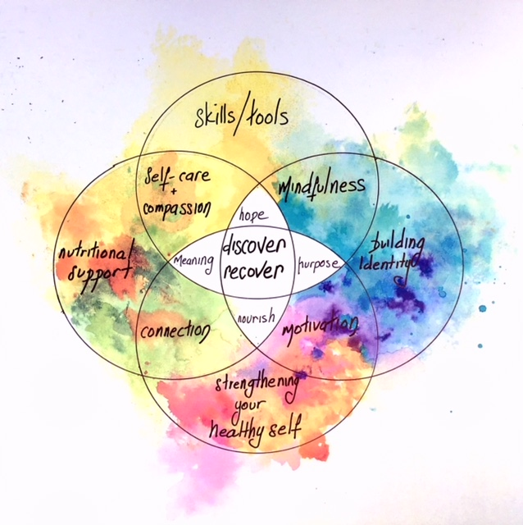

**Wesley Eating Disorder Centre**

**6 week support group for people new to eating disorder treatment.**

Wesley Eating Disorder Centre is offering a 6 week group program starting in Jan 2020 for those new to treatment, struggling with body image concerns, binge eating, restriction , purging or other behaviours

Facilitated by one of our skilled Eating Disorder Therapists, this group is recovery focused. Topics covered will provide foundational education and skills related to making positive change.

You will need to complete an assessment interview prior to starting the group plus seek a GP referral. You will also need private health insurance.

The group is designed for people who are:

* 18 years and over
* Able to commit to all 6 sessions
* Looking for group support
* Have received minimal clinical treatment before

The group will run weekly for 3 hrs on a Friday morning from 9.30-12.30pm with morning tea provided as part of the therapeutic program. Completion of the 6 weeks may then lead to participation in Wesley’s Eating Disorder Day Program.

To register you interested please contact: Michele Stewart, Wesley Hospital Ashfield (02) 97161449 or by email [michele.stewart@wesleymission.org.au](mailto:michele.stewart@wesleymission.org.au)